Promissory Note

13th June 2009

For value received the undersigned, Name__________, I promise to pay to the order of Mr. Justin Osagie Oboh., Amount___________ As Agreed on our terms and conditions if I still owe amounts under this Note, I will pay this note off in full.

Witness the hand of the undersigned.

Name

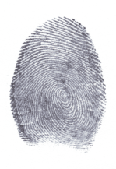
SIGNED;
Dr .Mrs. Jason Olivia (MINISTRY OF INSURANCE)
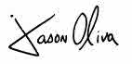
02/02/2009

